Dataset:

1) HELOC - Loan Delinquency Risk Performance, In bank view. (Drop)

2) LoanApprovalPrediction – In user view. Data volume too small - only obtain 599 or records. (Drop)

3) 2021 FHLBank Public Use Dataset – In user view, with Loan, Borrower, Property information. (Selected)

Federal Home Loan Bank (FHL Bank):

US government sponsored bank that offer lendable funds to eligible members, like community banks, credit unions. Link: [Home - FHLBanks](https://fhlbanks.com/)

Dataset Link:

[Public Use Databases | Federal Housing Finance Agency (fhfa.gov)](https://www.fhfa.gov/DataTools/Downloads/Pages/Public-Use-Databases.aspx)

Record Count:

|  |  |
| --- | --- |
| Borrower1CreditScoreValue | Count |
| 5 | 35769 |
| 4 | 18943 |
| 3 | 6892 |
| 2 | 2111 |
| 9 | 100 |
| 1 | 75 |

Data Description: 56 attribute, 63890 rows

|  |  |  |  |
| --- | --- | --- | --- |
| # | Field Name | Definition | Category |
| 1 | Borrower1CreditScoreValue | Credit Scores are separated into a range: 1=< 660, 3=660 < 700, 4=700 < 760, 5=760 or greater, 9 = Missing or Not Applicable | Borrower  (Target Field) |
| 2 | TotalMonthlyIncomeAmount | The total monthly qualifying income used for underwriting in whole dollars for all borrowers on the loan | Borrower  (positive relationship with credit score) |
| 3 | LoanAcquisitionActualUPBAmt | The Amount of unpaid principal balance in whole dollars when acquired by the FHLBank. | Loan  (mix relationship with credit score) |
| 4 | PropertyType | PT01=Single family detached; PT02=Deminimus PUD; PT03=Single family attached; PT04=Two family; PT05=Townhouse; PT06=Low-rise condo; PT07=PUD; PT08=Duplex; PT09=Three family; PT10=Four family; PT11=Hi-res condo; PT12=Manufactured home not chattel; PT13=Manufactured home chattel; PT14=Five plus multifamily | Property  (mix relationship with credit score) |
| 5 | PropertyUnitCount | Total number of units in the property | Property  (mix relationship with credit score) |
| 6 | FIPSStateNumericCode | 2 Digit FIPS State Code | Property  (mix relationship with credit score) |
| 7 | CensusTractMedFamIncomeAmount | The property’s census tract median family income. | Property  (mix relationship with credit score) |
| 8 | LTVRatioPercent | The loan-to-value ratio of the mortgage at time of origination. | Loan |
| 9 | ScheduledTotalPaymentCount | Term of the Mortgage in Months | Loan  (negative relationship with credit score) |
| 10 | NoteRatePercent | Interest rate on the mortgage at acquisition | Loan  (negative relationship with credit score) |
| 11 | ScheduledTotalPaymentCount |  |  |
| 11 | TotalDebtExpenseRatioPercent | Ratio of all debt payments to total borrower income. | Borrower  (negative relationship with credit score) |
| 12 | HousingExpenseRatioPercent | Ratio of mortgage principal and interest and housing expenses to total borrower income. | Borrower  (negative relationship with credit score) |
| 13 | Borrower1AgeAtApplicationYears | Age in years of the borrower at time application submitted; 999=Age not provided, 998=Not Applicable (Borrower might be a legal entity like an LLC) | Borrower  (positive relationship with credit score) |

Follow are the attribute mean values bar chart against credit score value ( 0 – represent missing values):

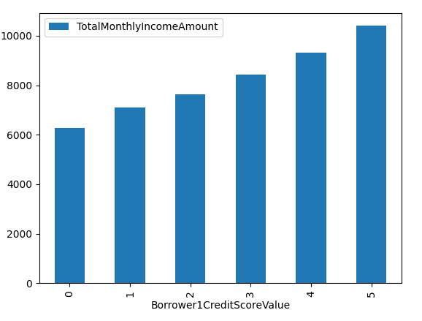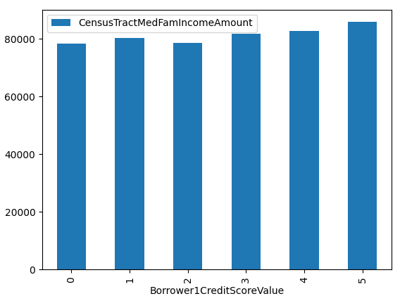

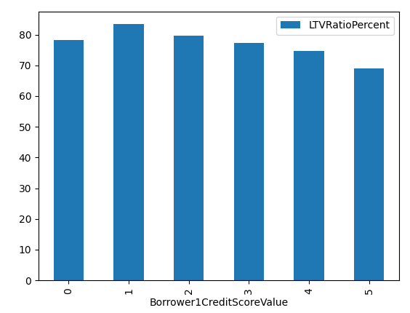 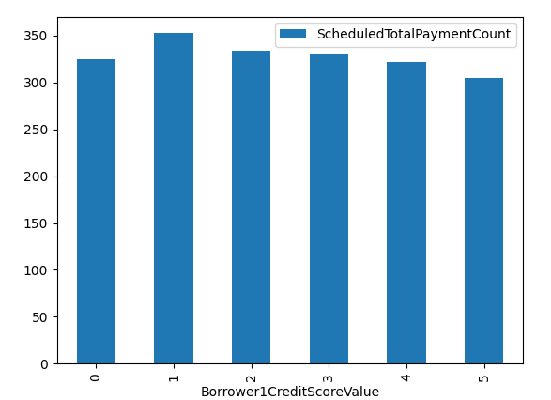

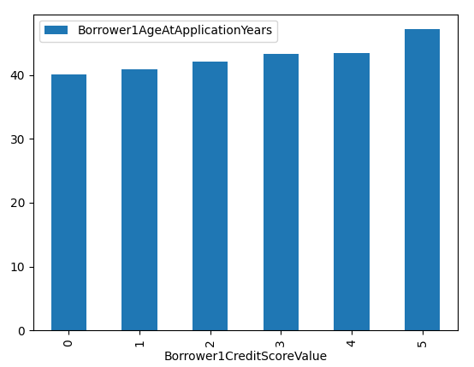 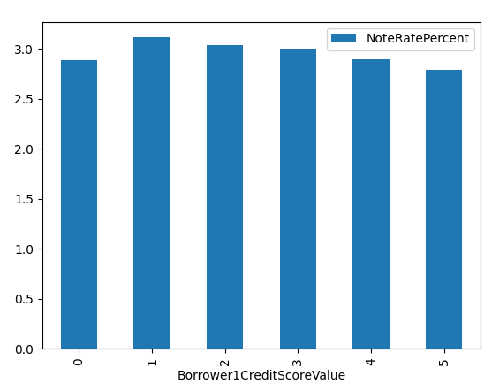

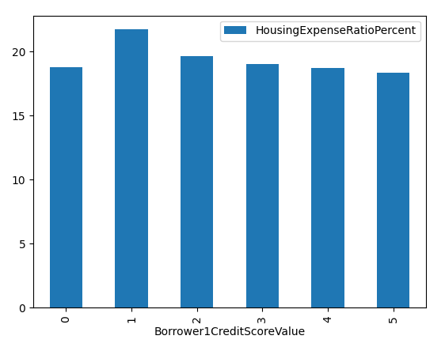 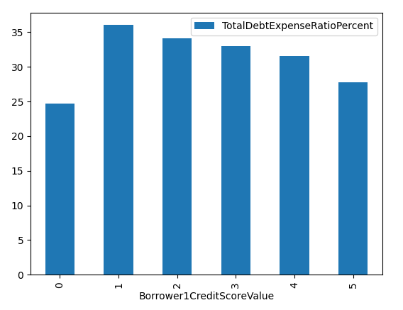

Property Type – record count % by each Credit Score Value:

PT01=Single family detached; PT02=Deminimus PUD; PT03=Single family attached; PT04=Two family; PT05=Townhouse; PT06=Low-rise condo; PT07=PUD; PT08=Duplex; PT09=Three family; PT10=Four family; PT11=Hi-res condo; PT12=Manufactured home not chattel; PT13=Manufactured home chattel; PT14=Five plus multifamily

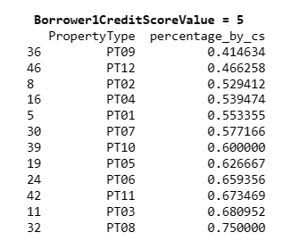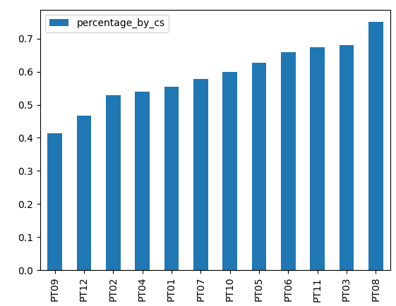

For example, PT08=Duplex is have 75% of records having Credit Score 5 value.

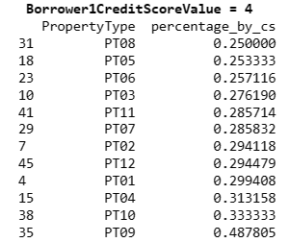 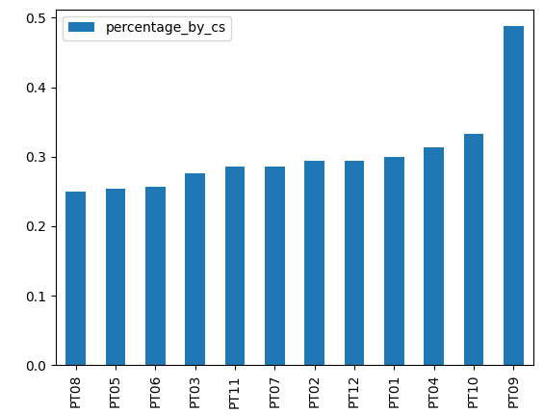

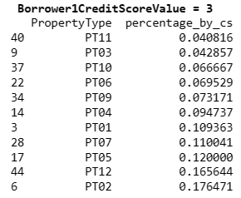 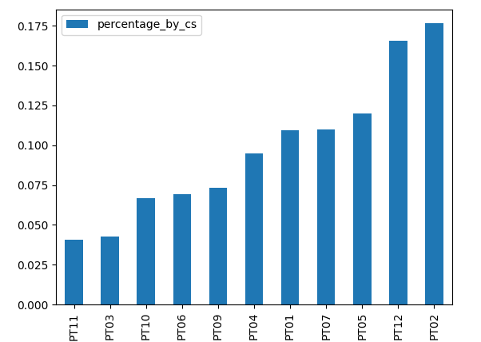 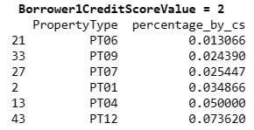 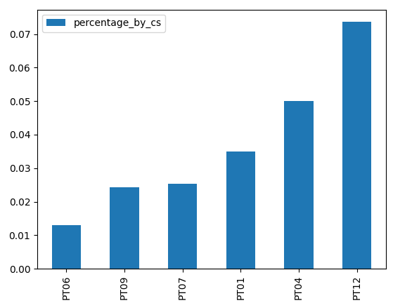

For example, PT12=Manufactured home not chattel is have 74% of records having Credit Score 2 value.

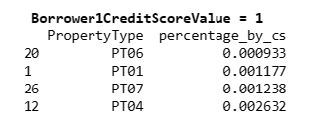 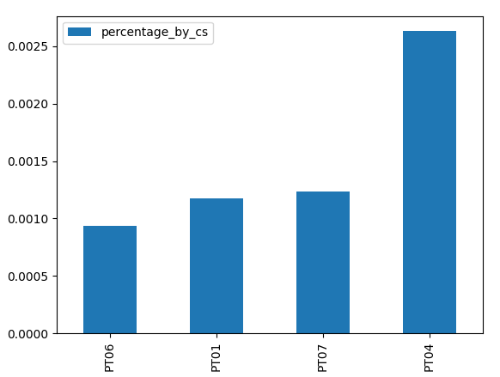

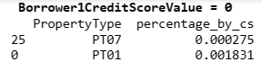 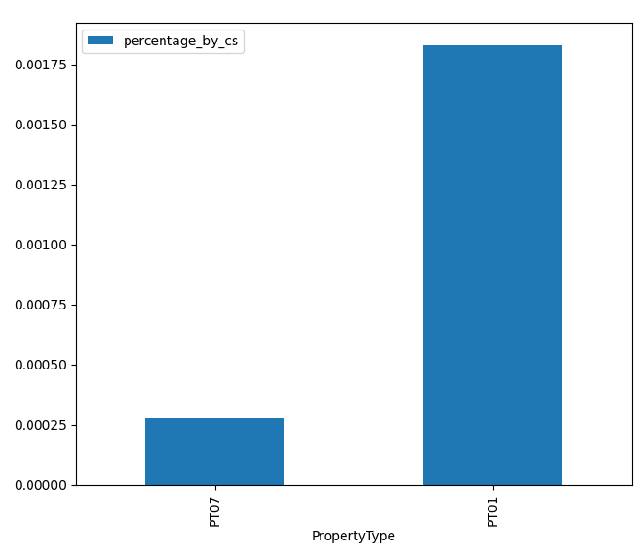

Outliner:

